**SMART WATER MANAGEMENT**

**PHASE-5**

TEAM MEMBERS :

1.ANUPRIYA M

2.YOGESHWARI

3.VISHNU PRIYA Y

4.VENISRI E

PROJECT OBJECTIVES:

TO TEST AND DESIGN THE HUBIDITY AND TEMPRATURE USING DHT22 SENSOR WITH RASBERRY PI PICO CODE

COMPONENTS :

* WOKWI
* RASBERRY PI PICO
* DHT22 SENSOR
* RESISTER
* CONNECTION WIRES

DIAGRAM SETUP

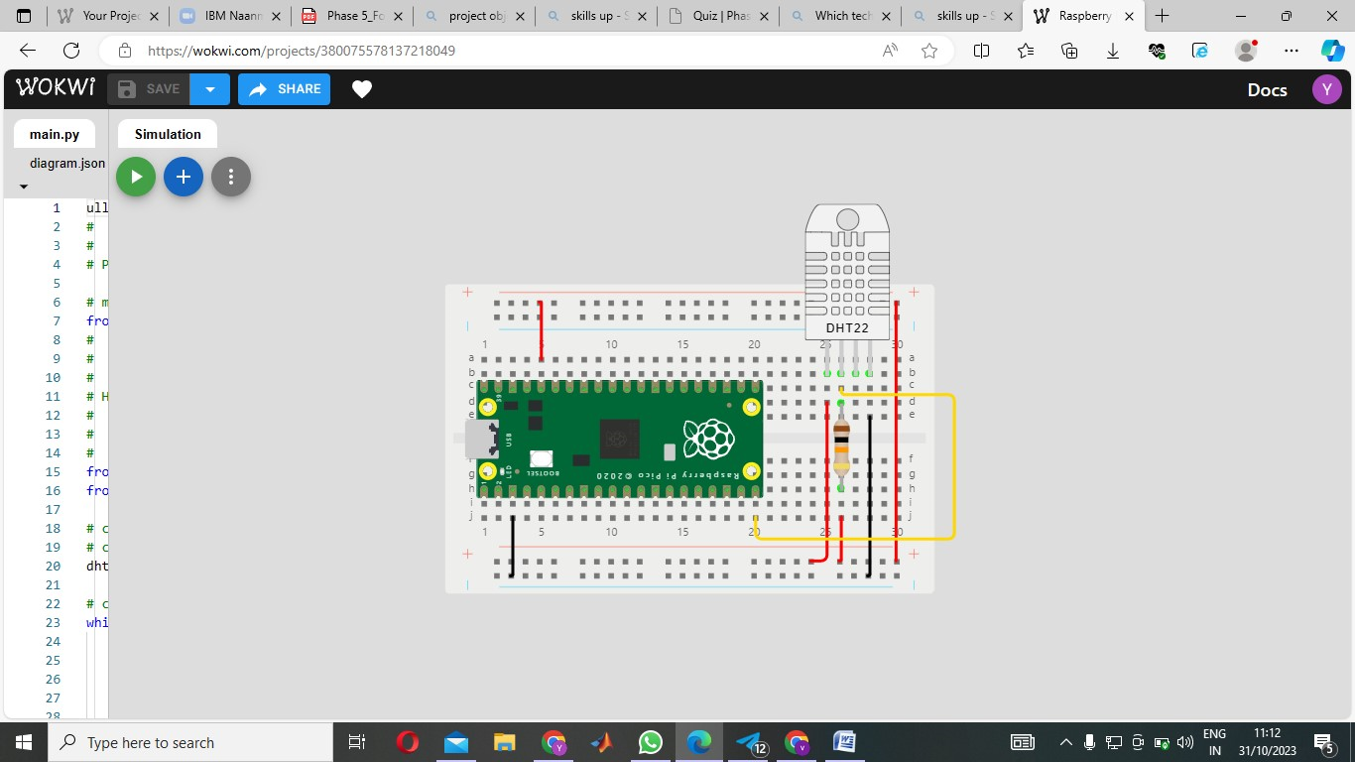

**Connections:**

* **dht1:VCC🡪VCC**
* **dht1:SDA🡪pico:GP15**
* **dht1:GND🡪GND**
* **pico:GND.1🡪GND**

**RESISTER:**

* **r1:1🡪dht1:SDA**
* **r1:2🡪GND**

**CODING**

ull-up resistor from DHT22 SDA Pin to 3.3V

#   DHT22 GND Pin to GND

#

# Programmer: Adrian Josele G. Quional

# modules

from machine import Pin# Project objectives:

#   Read temperature and humidity values from the DHT22 sensor

#   Display the sensor readings in the console

#

# Hardware connections used:

#   DHT22 VCC Pin to 3.3V

#   DHT22 SDA Pin to GPIO Pin 15

#   10k ohm p

from time import sleep

from dht import DHT22   # if the sensor is DHT11, import DHT11 instead of DHT22

# creating a DHT object

# change DHT22 to DHT11 if DHT11 is used

dht = DHT22(Pin(15))

# continuously get sensor readings while the board has power

while True:

    # getting sensor readings

    dht.measure()

    temp = dht.temperature()

    hum = dht.humidity()

    # displaying values to the console

    print(f"Temperature: {temp}°C   Humidity: {hum}% ")

    # format method or string concatenation may also be used

    #print("Temperature: {}°C   Humidity: {:.0f}% ".format(temp, hum))

    #print("Temperature: " + str(temp) + "°C" + "   Humidity: " + str(hum) + "%")

    # delay of 2 secs because DHT22 takes a reading once every 2 secs

    sleep(2)

**OUTPUT:**

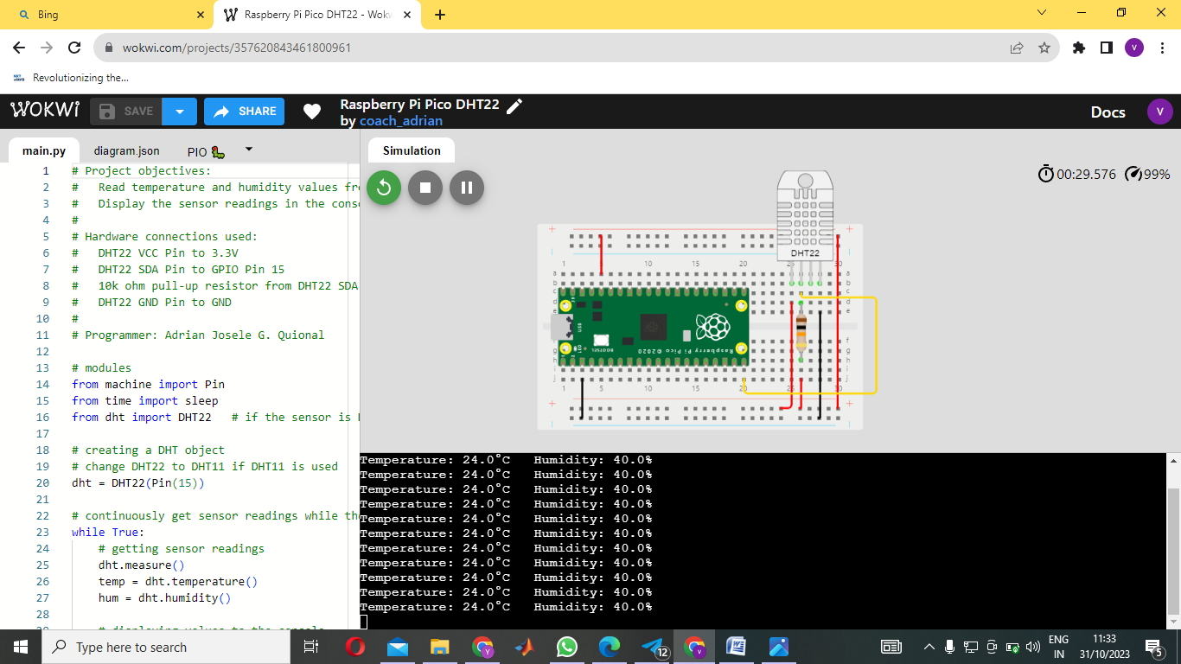

**Wokwi link:**

<https://wokwi.com/projects/380075578137218049>